**PROJECT DEVELOPMENT PHASE**

**SPRINT-I**

|  |  |
| --- | --- |
| Date | 18 November 2022 |
| Team ID | PNT2022TMID45665 |
| Project Name | Natural Disaster Intensity Analysis and Classification using Artificial Intelligence |

***OBJECTIVES:***

* To analyse the Intensity of the Disaster occurring.
* To classify Disaster correctly.
* To increase the accuracy of the model by using deep CNN.

***FLOW:***

The flow of analysis is as follows:

* Data collection
* Data preprocessing
* Model building ***STRUCTURE:***
* The dataset folder is created with Trainset and Testset.
* The Flask contains the templates folder and app.py script, disaster.h5 file.
* The templates folder contains home.html, intro.html and upload.html.

***PREREQUISITES:***

The required packages for python programming is installed through the Anaconda prompt by the following commands:

* Pip install numpy
* Pip install pandas
* Pip install scikit-learn
* Pip install opencv-contrib-python
* Pip install tensorflow==2.3.0
* Pip install keras==2.4.0
* Pip install flask

***PRIOR KNOWLEDGE:***

The knowledge about the following contents are learnt:

* CNN
* Supervised and Unsupervised ML
* Flask
* Clustering and Regression

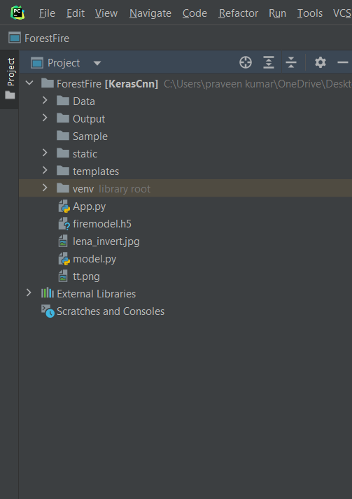

***COLLECTION OF DATASET:***

The images of Disaster-prone areas are collected and organised into the subdirectories. The images of four types of Natural Disasters, Cyclone,

Earthquake, Flood, Wildfire are collected and saved with the respective names. For more accuracy, Dataset with more images is selected and trained. The respective Dataset for the project is downloaded from the following reference link: [https://drive.google.com/file/d/11FdbTaJVrpwQmaCLV5gYYDQlfTeD0uz/view? usp=sharing](https://drive.google.com/file/d/11FdbTaJVrpwQmaCLV5gYYDQlfTeD0uz/view?usp=sharing)

***CREATION OF HOME PAGE:***

Using HTML and CSS, the Home page is created. From the Home page the User can be able to know the basics of the frequently occurring Disasters. The home.html page is given below:

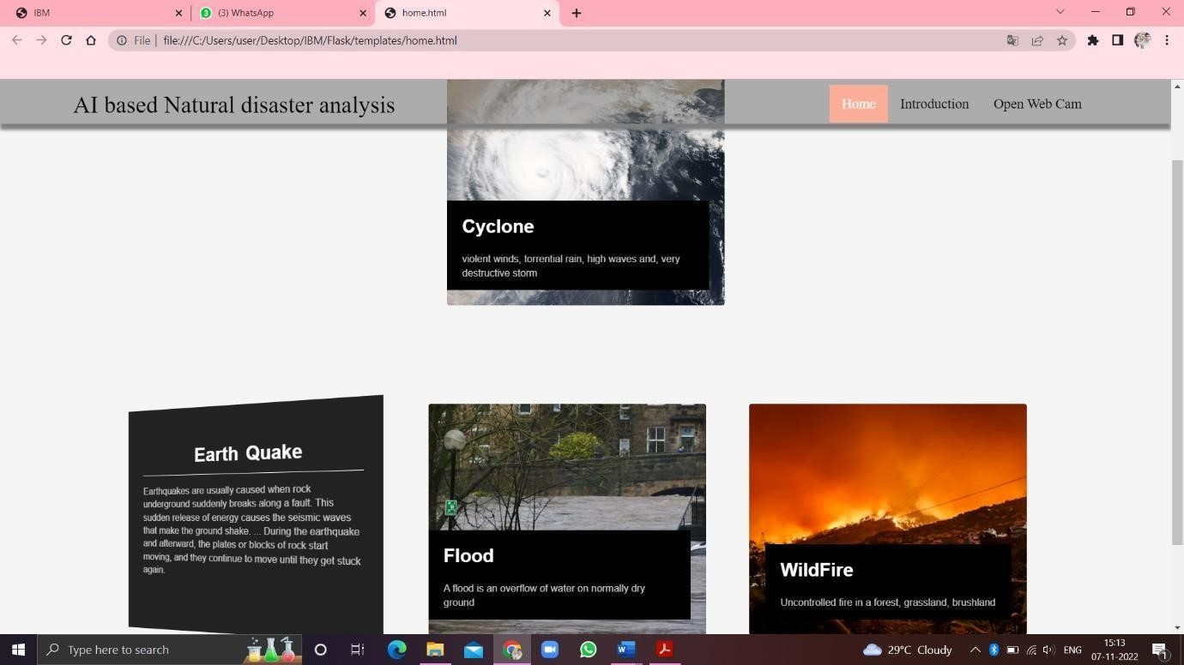

***CREATION OF INTRO PAGE:***

Using HTML and CSS, the intro page is created. From the intro page the user can be able to know about the project’s introduction or abstract. The intro.html page is given below:

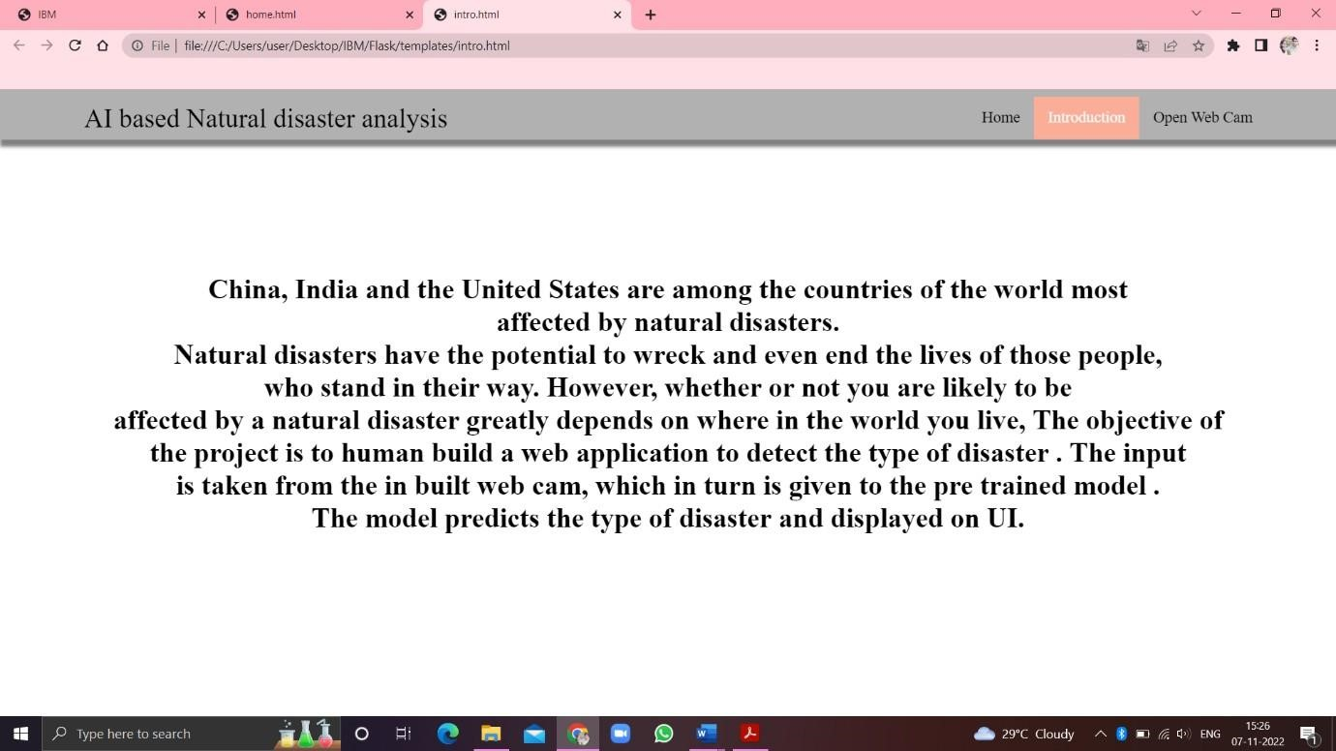

***OPENING WEB CAM:***

Using HTML and CSS, the upload.html page is created. Through this page User can be able to open the web cam to know about current disaster. The upload.html page is given below:

